Node js codes

**Let and var scopes**

let myname="Dexter" //global scope

function printmyname(){

let mylength=myname.length //mylength is local scope

if(mylength<10){

let minlength=10 //block scoped

var requiredlength=12 //local scope

console.log("Name length is: "+mylength+"it should be atleast"+minlength)

}

console.log(requiredlength) //it should be printed

console.log(minlength) //error as it is block scoped

}

console.log(myname)

printmyname() //one message,one error and one requiredlength

console.log(mylength) //error local scoped

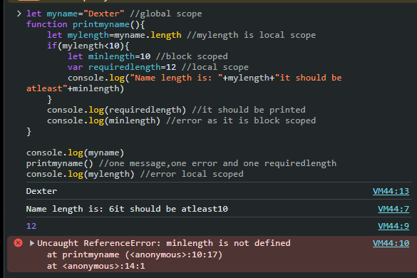

function foo(){

console.log(bar); //undefined

var bar=111;

console.log(bar);

}

foo()

is as good as writing

function foo(){

var bar;

console.log(bar); //undefined

bar=111;

console.log(bar); //111

}

foo()

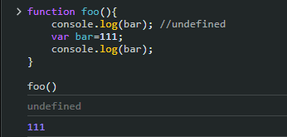

Default variable

